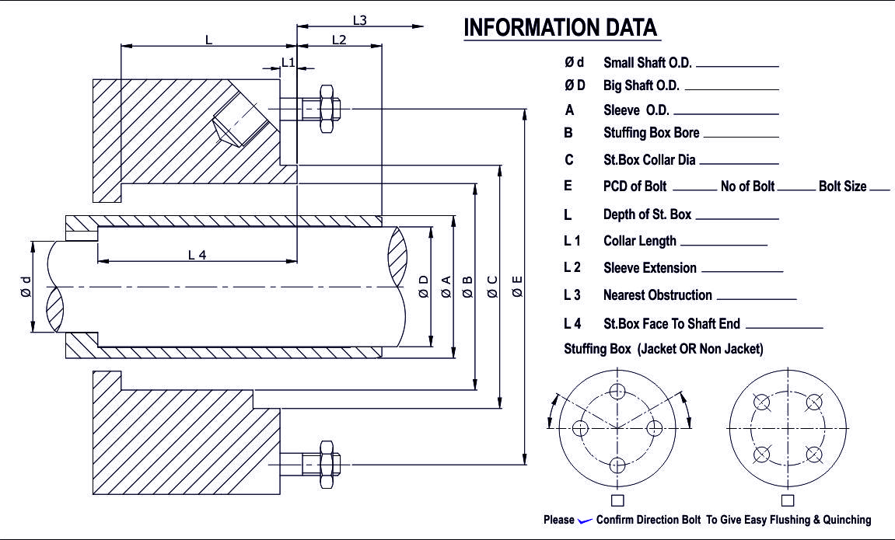
Ød Small Shaft O.D. _____________
ØD Big Shaft O. D. _______________
A Sleeve O.D. _________________
B Stuffing Box Bore ___________
C St. Box Collar Dia ____________
E PCD of Bolt ______ No of Bolt ______ Bold Size _______
L Depth of St. Box _________
L 1 Collar Length ____________
L 2 Sleeve Extension ____________
L3 Nearest Obstruction ____________
L 4 St. Box Face To Shaft End ____________
Stuffing Box (Jacket OR Non Jacket)
PUMP DATA
CLIENT NAME

MAKE: MODEL:

ITEM / TAG NO: M.O.C:

FLUID DETAILS & OPERATING PARAMETERS

MEDIA:

MEDIA DESCRIPTION: CLEAN SEWAGE ABRASIVE

SLURRY TOXIC HAZARDOUS

PRESSURE (Kg/cm²): SUC. PR: DIS. PR:

TEMPERATURE (°C): PUMPING TEMP (PT): MAX. TEMP:

SP. GR. AT PT VISC. AT PT

BOILING POINT FREEZING POINT

DIRECTION OF ROTATION (VIEW FROM MOTER END): CW ACW BOTH

PERCENTAGE OF SOLIDS GRAIN SIZE
REMARKS (IF ANY):

